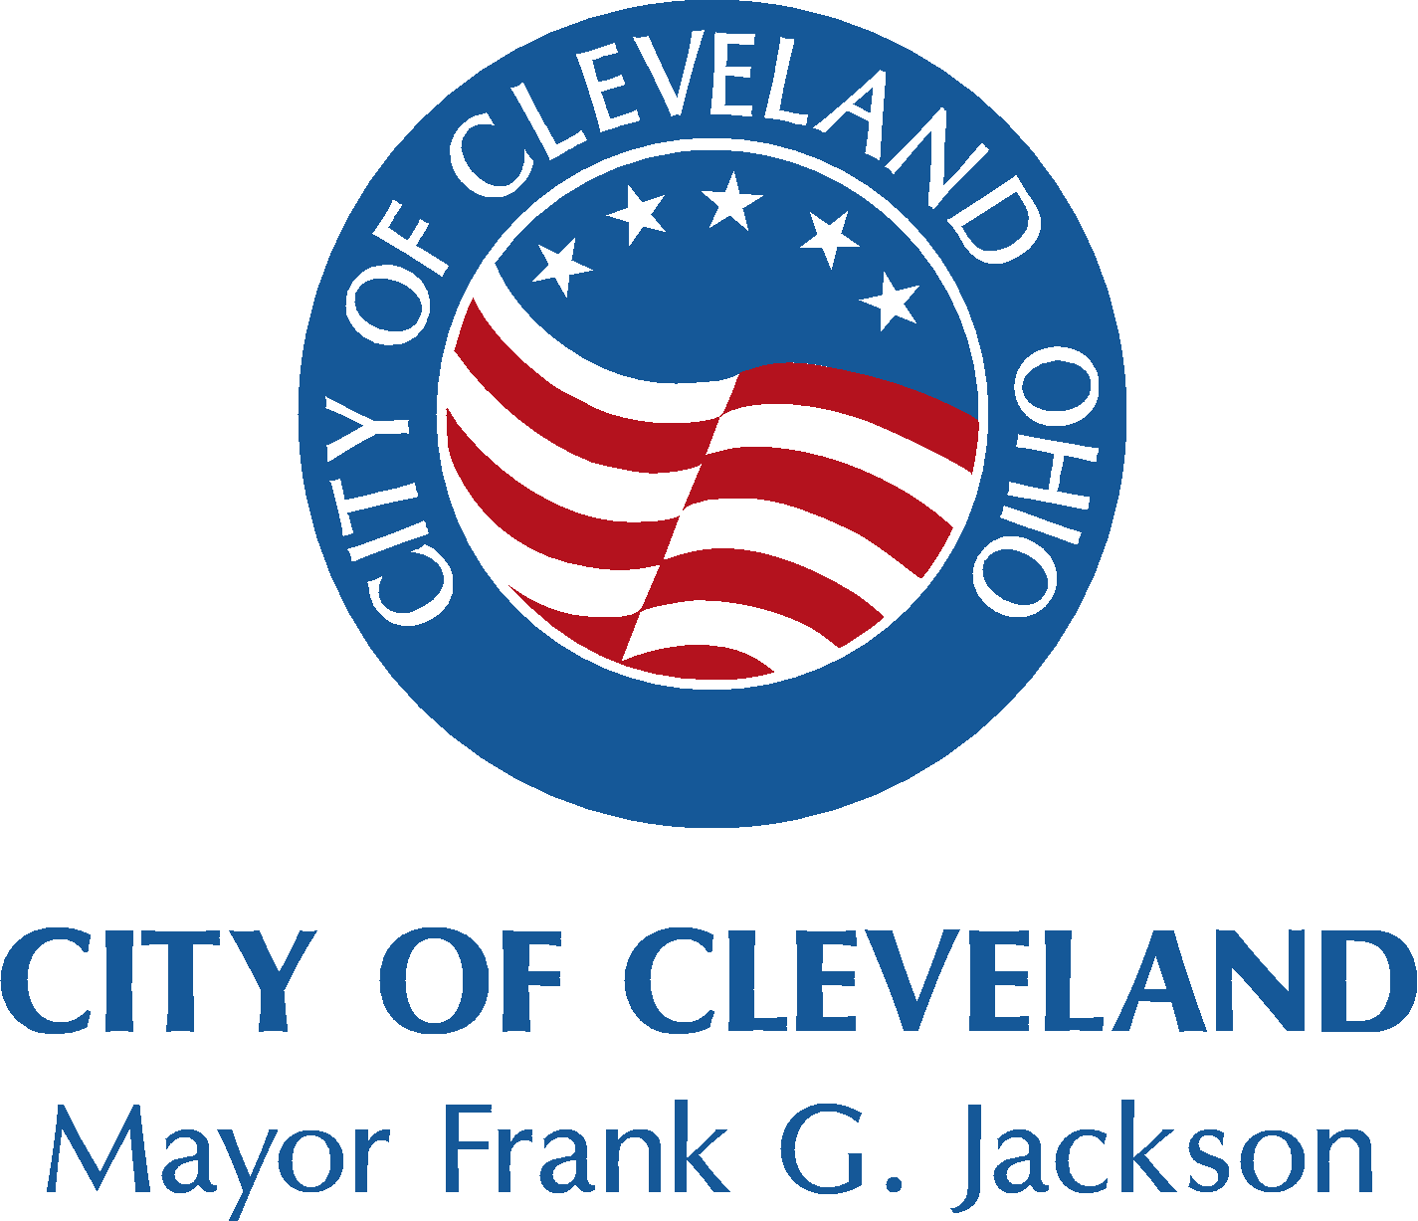
CITY OF CLEVELAND
Years 34 and 35 Community Development
Block Grant Public Participation Comments/Suggestions

WARD | NEIGHBORHOOD
If you were to choose one or two categories to focus federal block grant dollars on, which would they be?

 HOUSING  COMMERCIAL  INDUSTRIAL  RECREATION  SAFETY  SOCIAL SERVICES  INFRASTRUCTURE
 OTHER, EXPLAIN:
_________________________________________________________________________________
_________________________________________________________________________________

What programs or projects do you think would help address these problems?
_________________________________________________________________________________
_________________________________________________________________________________

Are you a  RENTER  HOMEOWNER
What problems/concerns do you have with your housing (e.g.: rental market, code enforcement, affordability, repairs, painting, insulation, plumbing, roof, furnaces, weatherization, safety, other? Please explain: _________________________________________________________________________________
_________________________________________________________________________________
_________________________________________________________________________________
_________________________________________________________________________________

If you are a homeowner, do you have any problems/concerns with ability to obtain:

 INFORMATION ABOUT LOW-INTEREST HOUSING REPAIR LOANS OR GRANTS FROM THE CITY OF CLEVELAND
 AFFORDABLE INSURANCE  LOANS FROM BANKS OR MORTGAGE COMPANIES  OTHER, PLEASE EXPLAIN:
_________________________________________________________________________________
_________________________________________________________________________________
_________________________________________________________________________________

COMMERCIAL
What goods and services are you able to purchase in your neighborhood?

GOODS:  CLOTHING  SHOES  CONVENIENCE ITEMS  HOUSEWARES
FOOD:  RESTAURANTS  DELI-STYLE OR CARRY-OUT FOODS ENTERTAINMENT:  LIVE MUSIC  CULTURAL ARTS SERVICES:  MEDICAL  LEGAL  ACCOUNTING  INSURANCE  DAYCARE  HEALTH & FITNESS  PHARMACY
 HOME IMPROVEMENT  AUTO REPAIRS  DRY CLEANING  OTHER:
_________________________________________________________________________________
_________________________________________________________________________________

What goods and/or services does your neighborhood lack?
_________________________________________________________________________________
_________________________________________________________________________________

What changes would you like to see in your neighborhood shopping areas? Check all you feel are important:

 PARKING AREA IMPROVEMENTS  IMPROVED BUILDING APPEARANCES  LITTER CONTROL
 SECURITY OR LIGHTING IMPROVEMENT  BUILDING/CODE ENFORCEMENT  OTHER, PLEASE EXPLAIN:
_________________________________________________________________________________
_________________________________________________________________________________

- over -

RECREATION
Which programs and services do you feel are currently successfully utilized within your community?
_________________________________________________________________________________
_________________________________________________________________________________

Which public parks or recreation facilities in your neighborhood would you like improved, and what do they need?
_________________________________________________________________________________
_________________________________________________________________________________
_________________________________________________________________________________

YOUTH/ELDERLY SOCIAL SERVICES and PUBLIC SERVICES
Federal government rules limit the amount of block grant dollars that the City can use for these programs. Knowing that, what do you and your neighbors feel are the most important priorities to direct funds for job training, job referral, medical, meals, shelters, safety, transportation? Please explain:
_________________________________________________________________________________
_________________________________________________________________________________
_________________________________________________________________________________
_________________________________________________________________________________

The largest growing segment of our community is the elderly and those approaching senior status. What services do you feel could/should be offered/expanded in your neighborhood to assist them in transition (e.g.: educational, social and employment opportunities, housing, legal, or financial planning)?
_________________________________________________________________________________
_________________________________________________________________________________
_________________________________________________________________________________

Which programs/services do you feel are lacking?
_________________________________________________________________________________
_________________________________________________________________________________
_________________________________________________________________________________

Which of the following age groups are under-served by existing social service/public service programs in your neighborhood?

 CHILDREN AGES 3-5  GRADE SCHOOL CHILDREN  JUNIOR HIGH STUDENTS  HIGH SCHOOL STUDENTS
 ADULTS  ELDERLY
Please explain why you feel these groups are under-served:
_________________________________________________________________________________
_________________________________________________________________________________
_________________________________________________________________________________
_________________________________________________________________________________

PUBLIC WORKS and INFRASTRUCTURE
Should federal block grant dollars be used for infrastructure needs?  NO  YES If you answered yes, please list three specific repair activities such as sidewalks (include addresses), streets, potholes (include location), street lighting, sewers, etc:
1)_________________________________________________________________________________
2)_________________________________________________________________________________
3)_________________________________________________________________________________

Please mail your survey response to: Public Information Section
Department of Community Development
601 Lakeside Avenue, Room 320
Cleveland, Ohio 44114
1/09 THANK YOU!

